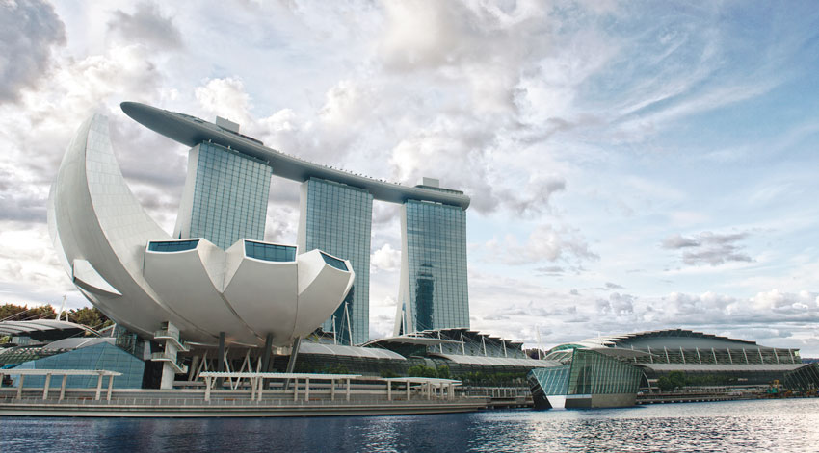

A

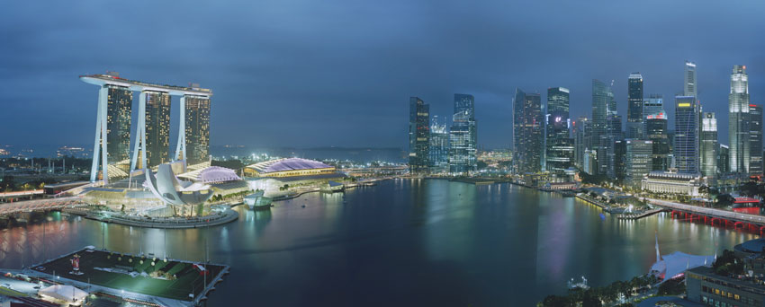

B

T\*0z0ZF#vZCV\*kHSm$jiOhwJ