Welcome to the 2024 Engineers Weekend in South Gippsland. Each year we visit a region in Victoria and enjoy friendship and fellowship with other Engineers, their friends and families.

We endeavour to work with Engineering Heritage Victoria to inspect at significant past & present Engineering Projects.

The Region of South Gippsland offers an enviable amount of attractions, eateries and accommodation. We will base our activity on the regions centre of Wonthaggi.

Come along and visit the engineering details of the San Remo Bridge, check out the Kilcunda Trestle Bridge, review the State Coal mine precinct

At just over an hour’s drive south-east of Melbourne, the Bass Coast offers over 180 kilometres of spectacular coastline, beautiful wilderness areas, scenic hinterland and a relaxed life style.
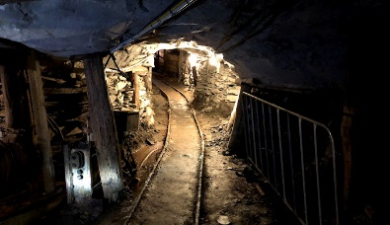
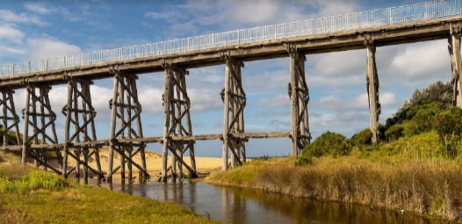
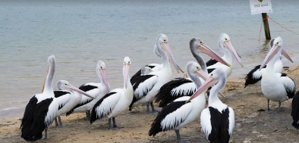

Victoria has a rich engineering heritage and this is your chance to see some of it, feel it and learn a bit about it!
This free, guided coach tour on the Saturday will take you to some of South Gippsland’s engineering landmarks: the Phillip Island Bridge, the Kilcunda Bridge and remnants of the State Coal Mine:
- The Phillip Island Bridge (San Remo to Newhaven) connects the mainland with Phillip Island. Constructed to replace a 1940 suspension bridge, the reinforced concrete, cantilever bridge opened in 1969. A FoxCam operates on this bridge.
- The Kilcunda Bridge is a 91m timber trestle over Bourne Creek that was constructed for the Victorian Railways to carry coal from the Powlett Coal Fields from 1911 until 1978.
- Wonthaggi’s State Coal Mine opened in 1910 to supply coal for Victoria’s railways. At its peak the mine produced 2,474t/day with Victorian Railways buying 90% of production.
Led by Matthew Churchward as our guide, this tour shines a light on the legacy left by Victoria’s engineering pioneers!

________________________________________________________________________________________________________________________________
NOTE: The whole weekend is premised, that all participants do so at their own risk.

Program of EVENTS:
Friday 11th October - evening:
Attendees arriving Friday evening, can meet up at the Workmen’s Club, 75 Graham St, Wonthaggi. VIC. 3995 - at approx. 6.30pm. Meals available PAYG
Saturday 12th October 2023 timetable:
10am Pick up in Wonthaggi at the Workmen’s Club (vicinity)
Travel through Dalyston, Kilcunda, look out to the cliffs of Cape Woolamai, through Anderson and down into San Remo
10:30am Meet at San Remo Park to view the Phillip Island Bridge. (& fox cam)
Feed the pelicans and enjoy a picnic in the park or lunch at the nearby San Remo Hotel.
Bus departs for Kilcunda to view the Bourne Creek Trestle Bridge.
Bus departs for Wonthaggi with information being provided about the coal mining history as we travel.
5:00pm Bus to arrive back at Wonthaggi to your accommodation or
5:30pm Bus returns to San Remo for folk who joined the trip at San Remo.
This is a self-catered event with stops along the way so bring or buy your food and drink.
6.30pm Dinner, speaker and fellowship at the Workmen’s Club PAYG.
Meet at the Coffee Lounge, Order from the Bistro menu
Sunday 13th October
10am meet at the State Coal Mine Garden Street Wonthaggi PAYG. Have a wander around this area check out the history, you may even get a cuppa PAYG.
12pm leave the State Coal Mine and drive to the Wonthaggi-Cape Paterson road and head
towards Cape Paterson then swing out along the coastal road, going past Eagles Nest and on to the RACV Resort at Inverloch for lunch
12.30pm RACV Resort for a Buffet Lunch - To be booked and paid for in advance

Accommodation
- M J McMahon Motel, 62 Watt St, Wonthaggi VIC 3995 – 03 5672 1083 Part of the Wonthaggi Workmen’s club Please mention you are with the Engineers Weekend.
- Wonthaggi Motel 40-44 McKenzie St, Wonthaggi VIC 3995 03 5672 2922
- Wonthaggi Park Lane Holiday Park 245 Graham St, Wonthaggi VIC 3995
- RACV Resort Inverloch 03 5674 0000

Cost:
This is a registration cost free event. PAYG - for all meals and accommodation. BUS is free
However, Sunday meal will need to be booked and paid for in advance $70 pp

Registration: Registration for attendance at the events to be confirmed by 26th September 2024,
NOTE: Early registration will assist the organising committee arrange details with venues.
Payments to: MJ & MF Duke Bank No 633000 Account No 107 230 732 please reference your Surname in the payment. We can then cross reference to your booking request.

For Registration or Further Information:
Chairperson organising committee  David J Eltringham, OAM, FIE Aust. EIPWEA, CP Eng (Ret)  Mob: 0418 147 482  Email: djelt@bigpond.com | Administration Support  Martin & Mary-Anne Duke  0458 788 747 / 0438 529 573  Email: fam_duke@yahoo.com

